Russell Bjella

ASEN 6008 Homework 3

2/15/17

1. R_mars = [-1.2816E8, -1.9060E8, -1.4748E4]

R_jup = [4.8347E8, -5.8744E8, -1.4629E5]

1. 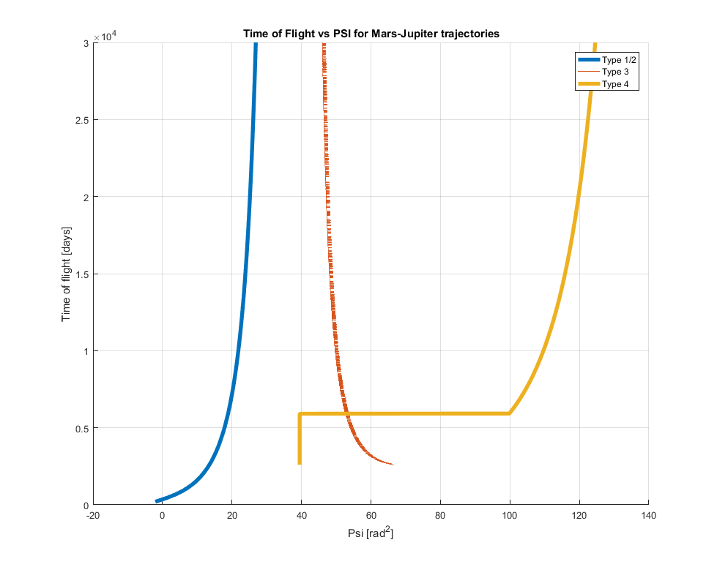Below: my code broke for low time of flight type IV transfers. I’m still investigating this, but this is what it gives so far.
2. Two things need to changed. First, the bounds on psi need to be adjusted to the appropriate minimum/maximum values for *n* revolutions. Next, the algorithm to iterate on psi needs to be adjusted to accommodate for the negative slope in type 3 transfers. I believe the problem with my code is that I do not have an elegant solution for this, so it breaks at extreme values in the type 4 case.
3. The shortest transfer time predicted by my code is 2600 days, with a psi value of 45.9872 rad^2.